Computer Says No
LOCOG came under fire (if one can excuse the pun!) recently, for failure to budget appropriately for Security provisions for the Games. Such a provision would have included significant provision for fire-related activity. Although LOCOG have now revised their original budget to better cater for security and fire concerns, they may have been relying additionally on the major financial investments that the Government had recently made in the development of a £1bn network of fire centres, powered by impressive IT systems costing a cool £2m.

Anti-Terrorist Technology
Designed in the wake of the September 11 attacks, the £423m Merton anti-fire centre constitutes one of nine centres across the country that has been designed to be able, for the first time ever, to co-ordinate a national response to a terrorist attack or natural disaster.

The regional centres were designed to have the capability to pinpoint the locations of fire engines and direct the nearest crews to problems. They would also use new technology to filter out hoax calls and ensure calls were answered at peak times, rather than having to rely on the Metropolitan Police for back-up.

Computer Says No
Unfortunately for LOCOG (and any organisation interested in anti-fire and anti-terror response, for that matter), the computer system that constituted the hub of the Anti-Fire Centre operations will not be operational in time for the 2012 Games.

Technological Failures
The computer software - which would also link England's 45 fire control rooms - is not ready as a result of what one MP called a "debacle", and what Brian Coleman, Tory Chairman of the London Fire Authority refers to as ‘...an IT cock-up to end all IT cock ups.’
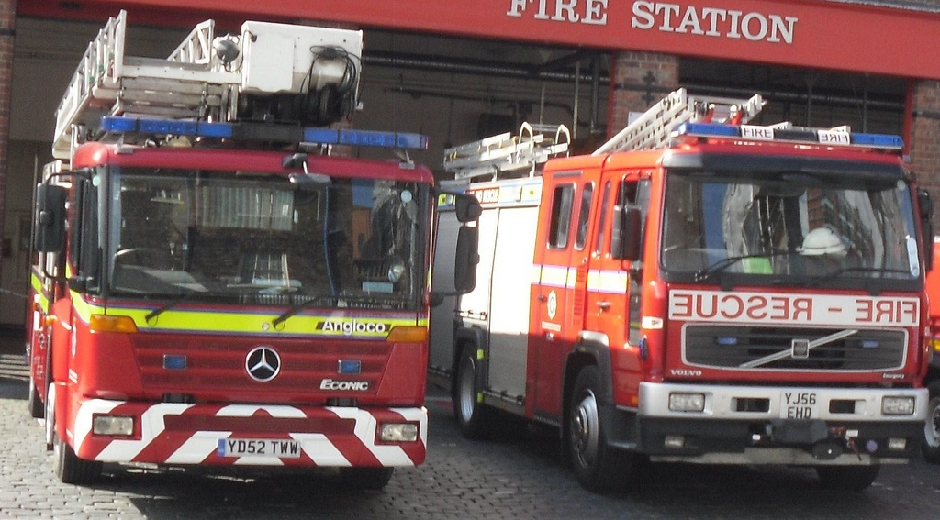
Image created by Police_Mad_Liam and reproduced under a Creative Commons licence.
He went on to comment that ‘Those of us who saw it coming several years ago kept telling the Government they were not in a position to deliver this before the Olympics. Nor is there any evidence that the software works. It's not going to be unsafe, the current system will see us through’.

The London "regional control centre" has already been criticised for its lavish design - it reportedly boasts a £25,000 coffee machine. It also houses 72 CCTV cameras and can withstand a nuclear attack; all of which would be useful, no doubt, if someone could successfully switch on the computers.

MPs are now investigating what the Fire Brigades Union refer to as a "gross waste of public money", which could eventually result in a bill of £1.4 billion. The National Audit Office says the software project will end up being £240 million over budget. Former Fire Minister Shahid Malik, however, argued that the system did not constitute part of the emergency preparations for the Games, with a spokesperson commenting that: ‘This change in the schedule has no significant impact upon security arrangements for the Olympics. The Olympic village will operate as an independent unit with its own communication centre covering police, ambulance and fire resources.’

The delay has also caused a loss in available employment for the Merton area, undoubtedly a blow given the rising unemployment caused already by the recession. Merton Council leader David Williams believes that “The disappointment from a Merton perspective is the centre appears to be close to physical completion, but the opportunity to generate some local employment opportunities has been lost for the foreseeable future.” - and that, interestingly, the Government are contradicting their earlier claims, made in 2007, by claiming that the Games do not need these systems. Earlier Government statements identified “the need for world class systems to be in place for the 2012 Olympics”.

The new centres were designed to replace Britain’s 46 existing fire control rooms at a cost of approximately £1bn, with the IT system – currently inoperable – claiming a cost of £200m.

START THE DISCUSSION
- Consider the social, environmental and economic factors that might have contributed to the failures outlined in this case study.

FIND OUT MORE
London Fire Brigade
http://www.london-fire.gov.uk/index.asp

CREDITS
© Oxford Brookes University 2010. oxb:060111:030dd

This resource was produced as part of the 2012 Learning Legacies Project managed by the HEA Hospitality, Leisure, Sport and Tourism Subject Centre at Oxford Brookes University and was released as an Open Educational Resource. The project was funded by HEFCE and part of the JISC/HE Academy UKOER programme. Except where otherwise noted above and below, this work is released under a Creative Commons Attribution only licence.

Exceptions to the Licence
The name of Oxford Brookes University and the Oxford Brookes University logo are the name and registered marks of Oxford Brookes University. To the fullest extent permitted by law Oxford Brookes University reserves all its rights in its name and marks, which may not be used except with its written permission.

The JISC logo is licensed under the terms of the Creative Commons Attribution-Non-Commercial-No Derivative Works 2.0 UK: England & Wales Licence. All reproductions must comply with the terms of that licence.

The Higher Education Academy logo and the HEA Hospitality, Leisure, Sport and Tourism Subject Centre logo are owned by the Higher Education Academy Limited and may be freely distributed and copied for educational purposes only, provided that appropriate acknowledgement is given to the Higher Education Academy as the copyright holder and original publisher.



Reusing this work
To refer to or reuse parts of this work please include the copyright notice above including the serial number. The only exception is if you intend to only reuse a part of the work with its own specific copyright notice, in which case cite that.

If you create a new piece of work based on the original (at least in part), it will help other users to find your work if you modify and reuse this serial number. When you reuse this work, edit the serial number by choosing 3 letters to start (your initials or institutional code are good examples), change the date section (between the colons) to your creation date in ddmmyy format and retain the last 5 digits from the original serial number. Make the new serial number your copyright declaration or add it to an existing one, e.g. ‘abc:101011:030dd’.

If you create a new piece of work or do not wish to link a new work with any existing materials contained within, a new code should be created. Choose your own 3-letter code, add the creation date and search as below on Google with a plus sign at the start, e.g. ‘+tom:030504’. If nothing comes back citing this code then add a new 5-letter code of your choice to the end, e.g.; ‘:01lex’, and do a final search for the whole code. If the search returns a positive result, make up a new 5-letter code and try again. Add the new code your copyright declaration or add it to an existing one.

